Analog vs digital

you cannot discern a high voltage from a low voltage in digital

continuous waveform vs non-continuous waveform

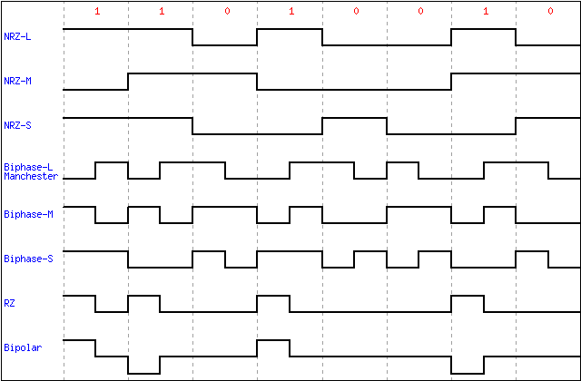

Baud rate

the number of times the signal changes per second

Bit rate

Depends on the encoding system the bit rate will be different

NRZ-L baud rate lower than bit rate

Manchester baud rate higher than bit rate

NRZ-S

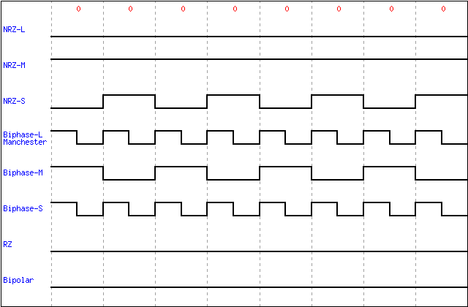

6/ increase the sampling rates

8/ 4000 baud worst case i.e 00000000000000….

6000 bps